

Pfeildorf:

Freistadt of Sudenland

By Alfred Nuñez Jr.

Additional Material and Assistance by the Server Goddess, Timothy Eccles, Ryan Wileman

Editing Assistance by John Foody and Jude Hornborg

Obligatory Copyright Statement
The Pfeildorf: Freistadt of Sudenland sourcebook is intended to be a completely unofficial addition to Warhammer Fantasy RolePlay owned by Games Workshop (GW). All relevant trademarks and copyrights are used without permission and in no way meant to challenge ownership to them by GW. The Pfeildorf: Freistadt of Sudenland sourcebook fully recognises said copyright and trademark ownership. Where possible, this effort conforms to the 'official' nature of the Warhammer World, and does so with the full acknowledgement of the intellectual ownership and legal copyright ownership of that material.

Table of Contents

Introduction 4
Background 4
History 4
Before Sigmar 4
The Coming of the Empire 4
Capital of Sölland 5
Age of Wars 5
The End of Sölland 5
Sidebar: Battle for Pfeildorf 6
Pfeildorf Rising 7
The Grand Barony of Sudenland 7
Sudenland in the 26th Century 8
The People 9
Politics/ Government 9
Provincial/ Freistadt Government 9
Foreign Affairs 10
Guilds 10
Economics 11
Crime/Law 11
Law and Order 11
Criminal Minds 13
Religion 13
Transportation 15
Entering Pfeildorf 15
Districts of Pfeildorf 16
Alderhorst 16
Söllhafen 19
Neusüdentor 20
Mórrsfeld 21
Schwarzwache 22
Reikhafen 24
Sidebar: The Societas Antiquarii 25
Nearby Villages 26
Merkelhausen 26
Schaffenhof 26
Gerechtfeld 26
Walnussbrun 27
Adventure Hooks 27
Murder on High 27
The Monkey in the Window 28
Appendix One-Feast Days in Pfeildorf 30
Appendix Two: Gazetteer of the Barony of Toppenheim 31
Map 1. Pfeildorf area 32
Map 2. Town of Pfeildorf (GM Map) 33
Map 3. Alderhorst District 34
Map 4. Söllhafen district and village of Walnussbrun 35
Map 5. Neusüdentor district and village of Gerechtfeld 36
Map 6. Mórrsfeld district 37
Map 7. Schwarzwache district and the village of Schaffenhof 38
Map 8. Reikhafen district and the village of Merkelhausen 39
Map 9. Town of Pfeildorf (PC Map) 40

Introduction

The Pfeildorf: Freistadt of Sudenland sourcebook is intended to provide a WFRP setting for those GMs who wish to centre their campaign in one of the larger towns in the southern Empire. The information contained herein assumes that the Imperial Civil War as described in the first edition “Enemy Within” campaign (including my Empire at War finale) has taken place. There is also information that relates to the Storm of Chaos of 2521-2522, for those who prefer to place their story in the aftermath of that conflict.

This sourcebook is written in a manner that will cover either version of WFRP, which basically means that stats (profiles, trappings, etc.) and prices of items are excluded in favour of base NPC descriptions. Of course, given that I lean towards WFRP1e, I might have missed keeping the text “edition-free” in some areas. GMs may want to consider adjusting to suit their version / game. Maps are included for both Players and GMs, with the latter being keyed to the descriptions of various locations.

Background

History
Like many of the Imperial towns founded in the first two centuries of Imperial history, Pfeildorf arose from humble beginnings. The following presents a brief overview of the town and its immediate surroundings.

Before Sigmar
Although twelve tribes are said to have unified behind Sigmar to wage war with Dwarf allies against the greenskin horde, there were many smaller tribes that existed in alliance with the larger tribes in the land that became the Empire. One of these was the Tratten tribe which along with the Agbard and Gesschebi tribes formed the Avermanni League. In turn, the Avermanni League was part of the Brigundian confederacy.

The tribes of the Avermanni League ranged from the area along the Upper Reik throughout the region of what would became the western region of the Averland province including the site where Nuln would be established. The Avermanni grew wealthy from their control of the nearby trading routes. They also constructed hillforts in the area to defend themselves from tribes seeking to gain advantage at their expense.

The Tratten tribe built their principle stronghold, Adlerhorst, on the crest overlooking the confluence of the Rivers Söll and Upper Reik from the south. This allowed the tribe to control trade between the Dwarfs of the Black Mountains and the cities of Tilea, with the lands of the Unberogens and Teutognens to the north.

Until the unification of the tribes by Sigmar, the Trattens were most often at odds with the neighbouring Menogoth tribe to the south. Raids for livestock and women were commonplace as the two tribes vied for regional dominance.

The Coming of the Empire
After the Battle of Black Fire Pass, Sigmar travelled throughout the newly unified Empire in order to settle conflicts among the tribes – both large and small – within his realm.

Though the Trattens and Menogoth s maintained their separate tribal identities, their blood had long intermingled with one another and neighbouring folk. Their customs and religious beliefs had also become virtually identical. With so much in common Sigmar was able to convince the tribal leaders to put aside their remaining differences.

The Tratten tribe voted to accept the Menogoth chief Markus as their lord with the provision that he marry the daughter of their elderly chief Cenwulf and establish his capital at Adlerhorst. With this agreement in place, Sigmar named Markus as the Ealdorman of the Imperial province of Sölland.

Capital of Sölland
The old hillfort of Adlerhorst covered the entire ridge from the cliff overlooking the confluence of the two rivers to the location of where the Temple of Sigmar now stands. During the time of Ealdorman Markus, two small settlements were established on the flanks of the ridge along the two rivers. In time, they grew into small towns as did the settlement on the ridge.

During the reign of Grand Baron Edgar Roebling in the third century, the three settlements were united into one town, which took its name from the original hillfort. The Grand Baron then began the process of rebuilding, including stone walls to offer the townsfolk protection from bandits, goblins, and ambitious vassals.

Taxation to secure the funds led to rioting which Grand Baron Roebling and his heirs put down with savage efficiency. Still, the land was not particularly wealthy at that time, and rebuilding was not completed for 30 years, by which time the grandson of Grand Baron Roebling was the Elector of Sölland.

Like many of the Imperial provincial capitals, Adlerhorst prospered in the Empire first millennia. Its location was ideal as it was rarely directly affected by the politics of Emperors and would-be Emperors in the cities to the North. Unfortunately, Adlerhorst did suffer with the rest of the country from the greed and depredations of the Drak Wald Emperors (the Hohenbachs). The ensuing Black Death – which brought down Emperor Boris the Incompetent and his cronies – also ravaged the population of Adlerhorst. Nearly 80% of the population died or fled the town in the vain hope of escaping the plague. The ruling Roebling family was decimated.

Age of Wars
After the brief recovery during the reign of Emperor Mandred Skavenslayer, the weakened Empire collapsed into petty fiefdoms held by powerful warriors and their retinues. Many wars and skirmishes were waged as the powerful sought to extend their dominion over the weak.

The battles fought over Adlerhorst was a microcosm of the Empire as a whole. Many who tried to capture the town – as well as some who held it – died in their struggles. Many structures built in the first millennium were destroyed and cleared so these could not be used by the opponents of the sitting lord of Adlerhorst. The old towns walls were torn down and their stones reused to re-fortify the old hillfort.

The Election of Emperor Otto VI in 1359 I.C. re-unified the southern Empire and brought an end to the Age of Wars.

The End of Sölland
Since the mid-14th century, Adlerhorst prospered as the southern Empire remained relatively peaceful. The capital of Sölland slowly expanded until it again reached the size it achieved during the end of the first millennium Empire.

In the 18th century, the Orc warlord Gorbad Ironclaw invaded the Empire from the east. His vast army swept up through Black Fire Pass and ravaged Averland and Sölland. Known more for his collection of toy soldiers and as a dandy than any martial prowess, Grand Baron Eldred von Durbheim of Sölland rode forth with his army from Adlerhorst to meet the enemy. The Battle of Staig was an unmitigated disaster and the army of Sölland was utterly destroyed. With his victory, Gorbad Ironclaw snatched the Sölland Runefang from the dead Elector’s cold hands

When the Grand Baron rode off to meet his fate with his knights and infantry, Kaptain Reiner von Mecklenburg, of the town’s militia, took command of the town he used the remaining stones from the deteriorated outer defences to strengthen its inner defences is . Von Mecklenburg also ordered the Honourable Guild of Bowyers and Fletchers to use their considerable talents to equip the remaining townsfolk with bows and arrows. In this manner, the townsfolk of Adlerhorst hoped to defend their town against the likely greenskin onslaught.

The victorious Orc Warlord swept across central Sölland, laying waste to everything before him. When he reached the River Söll near Geschburg, Gorbad divided his forces in two. He led the largest contingent across the

Sidebar: Battle for Pfeildorf
At the time of the Orc invasion, Adlerhorst had earned the nickname of “Pfeildorf” or “Arrow Town” due to the political power of the Honourable Guild of Bowyers and Fletchers and the skill of its numerous members at crafting bows and arrows. In fact, their collective effort was an important and dependable part of the town’s economy and it brought them renown in the southern Empire.
During the defence of Adlerhorst, the townsfolk fought bravely, firing arrows and hurling rocks at the Orc invaders. The Orcs, in turn, threw themselves at the hastily built-up defences with the expectation of breaking through to slaughter (and no doubt consume) the townsfolk. In between the attacks, the Orcs called out challenges and hurled insults at the people behind the barricades.
Stories telling of the courage and resourcefulness of the townsfolk during this dire time abound. One such legend tells about the retreat of the Orcs from the town.
After the defenders succeeded in throwing back the latest attack, the Orc war chief, his lieutenant, and a shaman approached just out of bowshot in order to taunt the weakening defenders. Behind them were the other Orc warriors screaming profanities and making obscene gestures in support of their leaders.
Suddenly, a large hooded man dressed as a woodsman appeared among the tired fighters with a large bow. Silently, he notched three arrows and pulled back the bowstring. The arrows flew straight to their respective targets, embedding themselves deep into the throats of each Orc leader. The three collapsed and died instantly, momentarily stunning their rank and file as well as the townsfolk of Adlerhorst.
Once awareness dawned, the dim-witted Orcs fled from the town as the defenders cheered. As the townsfolk turned to give thanks for their deliverance, the mysterious stranger who slew the Orc leaders was no where to be seen. Some believe the man to be an avatar of Taal, while others believe that the archer was Sigmar himself.
The arrows were retrieved by the grateful townsfolk. One of the arrows was awarded to the temple of Sigmar and a second to the temple of Taal. The third – which slew the Orc Warlord – was hung above the throne in the great hall of Castle Adlerhorst.

across the river and rampaged along the west bank, destroying Wissenland in the process. The smaller portion of the greenskin army – led by Snarlfang Bloodaxe – continued on the east bank with the intent of sacking Adlerhorst.

The battle for Adlerhorst was fierce and many on both sides fell. Kaptain von Mecklenburg’s choice of placing his defence along the boundaries of the old hillfort ensured that the townsfolk held the high ground from which they fired their missiles into the besieging horde. In the end, the greenskins gave up their attack in order to join Gorbad’s destruction of Nuln

Pfeildorf Rising
After the war, Wissenland absorbed what was left of the devastated Sölland. The entire region needed to rebuild after its ruin by the Orcs. Grand Baron von Durbheim, Grand Count Erich Adolphus von Meissen and his immediate heirs were killed in the Battle of Grünburg in the Reikland. Newly elected Nuln Emperor Dietrich II of the Reikland elevated Ulrich von Liebewitz to the rank of Grand Count of Nuln and Wissenland. As one of his acts, von Liebewitz rewarded Kaptain Reiner von Mecklenburg by granting him the title of Baron of Pfeildorf.

Under the rule of the von Mecklenburgs, Pfeildorf recovered from the ordeal and prospered. What remained of the old town walls were torn down so that the town could expand to accommodate its growing population. Many of the ruins of buildings destroyed in the siege were cleared away so sewers could be constructed to carry the wastes from the hilltop area of old Alderhorst to the rivers via conduits beneath the lower lying districts. The river ports were reconstructed as was the Hall of Justice and the temples to Sigmar and Verena.

The building programme created the burden of taxation and the period was marked by occasional rioting by the populace. With the outbreak of the Empire-wide Wizards’ War (1983 - 1991 I.C.), the population bore the taxes to re-build the town walls in a relatively co-operative manner. All desired some protection in case of attack by outlawed wizards and their vile, daemonic servants. Luckily, most of the battles were fought far from Pfeildorf.

The Grand Barony of Sudenland
In the latter part of the 23rd century, the von Mecklenburg family had become wealthy by virtue of income from their land holdings as well as substantial tax revenue resulting from an increase in demand for Sudenland wool, clothing, and shoes. Less well known is the number of peasants the von Mecklenburgs and other Sudenlander nobles forcibly evacuated from their villages earlier in the century in order to demolish these settlements to create more pastures for raising sheep. The nobles preferred to sell the wool for coin rather than collect taxes in the form of produce.

Their prosperity provided the impetus for the von Mecklenburgs to reach an accord with Nuln Emperor Alban von Liebewitz – who was rumoured to be in great debt to both Nuln and Miragliano banking interests – to separate the old province of Sölland from the more dominant Wissenland and establish it as a new Electoral province.

The province took the name of Sudenland in order to sever any connection to the old province of Sölland. The split with Wissenland was fairly amicable, by Imperial standards, which is to say they did not go to war. Emperor Alban’s agreement was not accepted in the North until Emperor Magnus the Pious issued the Edict of Pfeildorf in 2306. After over five hundred years under the ruling house of Wissenland, Sudenland became an Electoral province.

Sudenland in the 26th Century
Near the end of the 25th century rumours began circulating of some misfortune affecting the ruling von Mecklenburg family. Grand Baron Johann von Mecklenburg was often absent from the province for weeks on end. He also spent considerable time in Altdorf, which caused many of Pfeildorfers to feel slighted. In fact, Grand Baron von Mecklenburg had turned over the administration of Sudenland to his cousin, Baroness Etelka Toppenheimer, and her hand-picked advisors. The Grand Baron had no direct heirs and there were fouls rumours circulating about the fate of his missing younger brother.

In 2510, Grand Baron von Mecklenburg suddenly abdicated his position of Elector – with the Emperor’s apparent blessing – and turned over the rule of the Sudenland to newly elevated Grand Baroness Toppenheimer. He disappeared from public knowledge shortly afterward.

Like von Mecklenburg, the Grand Baroness did not have any direct heirs. Moreover, she did not consider any of her other close relatives worthy to be named heir other than Baron Olaf Sektliebe, the adopted son of a distant cousin and one of whom she became quite fond (salacious gossip notwithstanding) before succeeding von Mecklenburg. In a grand ceremony, Grand Baroness Toppenheimer declared Baron Sektliebe as her heir.

Growing tensions in the northern Empire between provincial rulers as well as the cults of Sigmar and Ulric broke out into a brief war in 2514. Though the battles were limited to the north, the southern provinces provided some support to the provinces nominally supporting the Sigmarite faction. At the end of the conflict, Grand Countess Emmanuelle von Liebewitz re-exerted her authority as ruler of Wissenland while maintaining her Court in the staatstadt of Nuln.

During this time, unsubstantiated stories began to circulate about Baron Sektliebe’s immoral activities. These deeds ranged from depraved debauchery to worshipping proscribed gods to treasonous acts to witchcraft. These rumours soon reached the Nuln Court.

In 2515, Grand Countess von Liebewitz moved swiftly. In what could be best described as a coup, the Grand Countess brought the matter before the assembled Electors. After much argument and presentation of evidence, Grand Baroness Toppenheimer agreed to relinquish Sudenland’s Electoral status and the province’s independence in order to retain her lands and title. As a condition of the agreement, an Imperial charter was issued granting the Pfeildorf (including its adjacent settlements) Freistadt status with the requirement that the to-be-formed town council pay a specified annual tribute to the Baroness as well as provide troops as needed.

When the news of the loss of Sudenland’s more than 200 years of independence reached town, the people pointed the blame for their loss of status towards the now missing Baron Sektliebe. They accepted the re-unification with Wissenland without much opposition, pragmatically preferring the least amount of disruption to their livelihoods.

The now reduced Baroness of Pfeildorf returned from Altdorf and, in a simple ceremony, named another nephew, Baron Markus Toppenheimer, as her new heir.

Life in Pfeildorf began to settle down. The outbreak of the Orc War of 2520 near Black Fire Pass and the 2521-2522 invasion in the northern Empire and Kislev changed all that. Many young men joined local Pfeildorf regiments, raised to fight in these wars, only to die far from their homes and families. The shortage of men was keenly felt in the aftermath of war, causing additional anxieties among the people of the once capital of Sudenland.

The People
As with other Sudenlanders, townsfolk in Pfeildorf tend to be straightforward, friendly folk with little tolerance for those from the larger cities who patronise them as poor cousins. Pfeildorfers value honesty in their interaction with others and have little patience with fast-talking charlatans, especially those from other regions of the Empire. Even when confronted by individuals putting them ill at ease, Pfeildorfers remain polite, but firm.

Many Pfeildorfers prefer practical styles to their clothing, though the nobility have developed a proclivity for the latest fashions emanating from Nuln. Whatever finery they may own is usually displayed during the various religious festivals observed in and about Pfeildorf.

Historically, the Pfeildorf townsfolk have good relations with the Dwarf kingdoms in the Black and Grey Mountain. The town does brisk trade with their southern and western neighbours with trade usually conducted along the River Söll and Upper Reik.

A number of Dwarfs have lived in Pfeildorf for many generations, a presence stretching as far back as Sigmar’s time as Emperor. The Expatriates Dwarfs remember the protection afforded to their ancestors by the people of Pfeildorf during the Dark Persecution initiated by Emperor Ludwig the Fat in 1013. Unlike other cities and towns in the Empire, there are no Dwarf quarters or ghettos in Pfeildorf. The Dwarfs live among the rest of the people throughout the town.

There are few Elves who have called Pfeildorf home over recent years. These have migrated from the Loren Forest in Bretonnia. They generally arrive into the Empire by way of the Montdidier Pass near the small southern Wissenland town of Kreutzhofen or the Grey Lady Pass near Übersreik in southern Reikland. In many cases, the Loren Elves are wanderers and seldom stay in Pfeildorf for more than a few years.

A small number of Halflings have settled in Pfeildorf, though many prefer the surrounding villages to the town itself. Like the resident Dwarfs, many of Halflings have lived here for generations and have greater allegiance to the people in Pfeildorf than they do to their brethren living in the faraway Moot.

In the last century, a number of immigrants from Tilea and Bretonnia, most of whom have come from the Miragliano and Quenelles regions respectively, have made their way to the Pfeildorf area. . Many are farmers, artisans or merchants looking for a better life and consider the Empire – despite its recent troubles – as more tolerant and less oppressive than their native lands.

Though tolerant, the typical Pfeildorfer tend to view the two groups of settlers through the lens of ill-informed rumours and stereotypes. Some still perceive the Tileans as little more than shifty thieves plotting to stab the unwary in the back and rob them. Bretonnians are viewed with some contempt as discourteous idlers who suffer from some misplaced sense of superiority.

Politics/ Government

Provincial/ Freistadt Government
As the capital of Sudenland, Pfeildorf is the seat of the provincial government. Grand Baroness Toppenheimer does not actually participate in the mundane affairs of government, though she does attend meetings of her Privy Council from time to time. Instead, she grants her councillors great latitude in running the affairs of state so that she can maintain her lifestyle – which is rather modest when compared to other Imperial nobility.
The Privy Council consists of seven members, five of who are drawn from the great noble families of Sudenland. Of the remaining two, one represents the collective interest of Pfeildorf’s guilds and the other is elevated from the governmental bureaucracy (generally based on merit rather than nepotism). The last position bares the title of Privy Secretary and is currently occupied by one Franz Walsinheim, a diligent man thoroughly obsessed with the preservation of Toppenheimer’s rule, more so after the incident involving Baron Sektliebe and the subsequent absorption of Sudenland by Wissenland.

The change from capital city of an independent Sudenland province to a Freistadt within a larger Wissenland entity fundamentally altered the government of Pfeildorf. While Baroness Toppenheimer still holds her Winter Court at Castle Alderhorst, she was obliged to move her Privy Council and Summer Court to Castle Mecklenburg outside the village of the same name.

A new city council was created to govern the Freistadt of Pfeildorf in 2515. As one would expect from a town whose wealth derives from the wool and related trade, three seats of the eleven member council are selected from the masters of the leading guilds (see below), including the one selected to a seat in the Baroness’ Privy Council. One seat is set aside for an elected alderman from each of the town’s six districts. The last two seats are occupied by a representative of the established religions (set to rotate on an annual basis between the Mórrian, Sigmarite, and Verenan churches: the cult of Taal declined to participate) and the commander of the town’s garrison, currently Baron Ulrich von Bernau. In addition, Franz Walsinheim attends the monthly council meeting in his role of (non-voting) advisor and representative of the Baroness’ interests.

Foreign Affairs
The government of Pfeildorf remains on friendly relations with its Imperial and Dwarf neighbours as well with the neighbouring provinces. The provincial government essentially works on the premise that it is in its best interest to not offend its trading partners, even those located on the far-flung eastern frontiers.

Several of Pfeildorf’s trading partners have small embassies located within the town wall. The larger of these are trade missions for the Dwarf kingdoms of Karak Hirn and Karak Norn and the Tilean city of Miragliano. In addition, trading companies from the Imperial provinces of Averland and Wissenland as well as Nuln have established a presence in Pfeildorf. These embassies tend to support the mercantile interests of their people as well sustain their merchants who travel to the Sudenlander town on business.

Guilds
Guilds are also a major political force in Pfeildorf. These regulate the economic issues and rules of their respective trade throughout Sudenland. The guilds control their members in other parts of the province through use of smaller outposts in Geschburg, Kroppenleben, and Steingart.

The most influential of the Pfeildorf guilds are the Shearers’, Tailors’ and Weavers’, Tanners’, and Cobblers’, who also happened to be the ones involved with the major portion of the town’s exports. The four guilds co-operate well in most areas as they recognise that unity brings a competitive advantage and higher profit. On an one-year rotational basis, a Guildmaster from of these major guilds holds the chair of the Guilders’ Council – as well as a member of the Baroness’ Privy Council.

Other guilds are important to Pfeildorf and make certain that the four major guilds represent their respective interests as well. These guilds include the Artisans’ (a mix bag of craftsman not covered by other guilds), Bowyers’ and Fletchers’, Builders', Rivermen, Smiths’, Stevedores', Teamsters', and Vintners’.

Economics
Sudenland is mostly an agricultural province, producing raw material, foodstuffs, and wine for trade to other provinces and the nearby Dwarf kingdoms. In return, Sudenland towns import finished goods. Some of the raw material – particularly wool and sheepskin – makes its way to Pfeildorf, where these are turned into other products for trade.

The Pfeildorf clothing industry (weavers and tailors) uses the high-quality Sudenland wool to produce articles of clothing – cloaks, tunics and trousers – that are in high demand throughout the Empire. The reputation of Pfeildorf wool garments were such that, after the war in 2514 devastated the northern provinces, trade agreements were signed with representatives from Middenheim for winter uniforms for the Knights Panther and the other elite units of the Graf’s army. Similar agreements were reached with the Grand Prince of Ostland, as well with several Knightly Orders.

In addition to wool clothing, the reputation of Pfeildorf’s leather goods is also rising. Sheepskin shoes have become the rage in the Nuln high society. Moreover, many of the colleges of Magic and a number of the religious houses in the southern Empire prefer Pfeildorf vellum for their scrolls and books.

In contrast to the aforementioned trade products, the demand for the products manufactured by the members of Bowyers’ and Fletchers’ Guild have declined with the growing popularity of handguns in the various provincial armies.

Pfeildorf ale tends to be locally brewed and only traded in the immediate area. Many of these breweries reprocess the strong beer mash used in creating their higher quality brew to produce a high quantity of the weak beer that is widely and cheaply sold in the taverns (after all, the water from the rivers is rather unhealthy).

In recent years, one particular master brewer – Torsten Ecclestein, owner of the Schwarzbrunn Brewery – has been able to drastically increase his production of his trademark pilsner while keeping costs down. This effort has resulted in complaints being filed with the Guilders’ Council by Herr Ecclestein’s competitors claiming unfair advantage. Uncertain of whether his bribes to the Council will have the desired effect, Herr Ecclestein has begun the process of buying taverns in Pfeildorf and the surrounding area (under the company name of Ecclestein Hostelries of Pfeildorf) in order to exclusively sell the ales and weak beer he brews.

The wine merchants in Pfeildorf aggressively promote not only the wines produced by local vintners, but also act as middlemen in the trade of Sudenland’s other wines with the cities to the north along the River Reik. Some of the more notable wines include Wittenhausen Zweigelt, Sudenland Gewürztraminer, Rhya’s Ruby Delight, and Althausen Reisling.

Crime/Law
Like any other place in the Empire, Pfeildorf has its share of criminal enterprises as well as laws that attempt to curtail illegal activities or deeds putting public order and safety at risk.

Law and Order
The main objectives for the Guild of Lamplighters and Watchmen are to: (1) ensure that all street lamps in the town are lit within one hour of sunset and extinguished at dawn; (2) call out the hours of the night and the state of their patrol (“one o’clock and all is well”); and (3) take into custody or spot fine anyone disturbing the public peace.

Several patrols of five to eight men are assigned to the solidly-built Watch barracks located in each district. Several small holding cells have been constructed beneath these stone buildings. Disturbers of the peace and minor violators may be levied a spot fine (anywhere from 5 shillings to 2 GCS) or kept in these cells overnight until a proper punishment can be determined (usually five to ten lashes to be publicly administered or several days in the stocks outside the gates of Pfeildorf). Those accused of more serious crimes wait in the Barrack cells until an armed detachment of guards escort them to St. Quintus Prison.

Located in the Mórrsfeld district, St. Quintus Prison was original built in the 19th century as a fortress to defend the southern approaches to the town. When the town walls were rebuilt in the late 20th century, the fortress was converted into a prison for enemies of the state as well as their accomplices and servants. The office of warden of St. Quintus Prison is an inherited position passing from father to younger son and falling under the purview of the Privy Secretary. The current office holder is Baron Sigismund von Fraunhofer, a no-nonsense disciplinarian who specialises in breaking obstinate criminals and traitors.

When the time of their trial is at land, the accused is brought by armed escort to the Hall of Justice. Word is spread when one of the more infamous criminals is scheduled to make their final trip by mule-pulled cart. This notice provides the townsfolk plenty of time find their place on the procession route so they can pelt the criminal with rotten fruit and vegetables in addition to hurling insults and making obscene gestures.

In order to prevent disruptions, attendance at the courtrooms is limited to injured parties, those who can prove a legitimate interest, and a presiding magistrate. Jury trials are the most common for most trials, consisting of a panel of nine jurors. If the crime is particularly heinous (e.g., rape, sedition, impersonating a noble, premeditated murder), three magistrates will sit in judgment instead of empanelling a jury). When a guilty verdict is reached, a town crier will announce the news outside the Hall in the Alttorplatz before the convicted is returned to St. Quintus. If an execution is warranted, then the scaffolding is erected in the middle of the Alttorplatz. The construction of the structure is indicative of whether the punishment will be a simple hanging, beheading, or drawing and quartering. The mood at the time of an execution is rather festive.

Other punishments are conducted behind the walls of the prison, ranging from the removals of the hands of thieves to the interrogation (torture) of those considered enemies of the state. In addition, there are certain political prisoners – such as agitators, anarchists, and demagogues – who simply disappear within the cold, dank labyrinth of cells beneath St. Quintus.

Guild and Ecclesiastical Courts also exist in Pfeildorf. The former is situated in the basement of the Sudenland Guildhouse. Trials involving guild members are adjudicated over by a tribunal of three appointed legates of the Guilders’ Council. Those found guilty can expect punishments in the range of a fine of 2-5 GCs for minor violations to a suspension of practicing one’s craft for a limited duration to expulsion from the Guild and town for gross violations of Guild Laws. In some cases, the accused may be turned over for trial to the Hall of Justice.

Crimes committed by the various priesthoods are never referred to the Hall of Justices. The Ecclesiastical Courts retain full jurisdiction over their members. All trials are conducted in secret beneath the Temple to Verena presided over by representatives of the cults of Verena, Sigmar, Mórr, and Taal. In addition, the Ecclesiastical Courts holds the writ of authority to bring any accused of dark witchcraft, necromancy, or demonology before them to answer for their crimes against the Empire and Humanity. Any found guilty are rarely heard from again.

Criminal Minds
As with any of the large Imperial towns and cities, Pfeildorf suffers from crime ranging from petty robbery to organised criminal gangs. In fact, any newly arrived thief or cut-throat looking to set up shop in the Sudenland capital would be well-advised to join one of the gangs before attempting any job. The first warning is for courtesy, but the second is likely to involve bodily harm for independent operators.

The two largest gangs are the Heinkel and Dornier families. Both are currently engaged in an uneasy truce since the last eruption of warfare in 2510 weakened the two families considerably. A third organisation, the Luciano-Lansky gang from Wissenburg, have been making inroads in drug, prostitution, and smuggling rackets.

The Heinkel family is led by its matriarch, Grandmother Agnes, a hard-edge woman in her early 60s. She lost her husband, Otto, and three of her four sons in the war against the Dornier organisation as well as other family members. Emmerich Heinkel is a calculating, ruthless man and heir apparent who made his mark in the family’s protection racket. There are rumours that he is looking for a means to retire (remove, if need be) his mother so he can finally crush the Dornier family. The Heinkel family’s operations are centred in the Reikhafen and Schwarzwache districts.

Claudius Dornier is the leader of his crime family. In his mid-50s, Claudius is a survivor. His family was able to fight off the onslaught from the Heinkel family although it cost him his oldest son and youngest daughter. Claudius loathes the Heinkels and is currently recruiting new members for the next war. Claudius’ surviving son, Karl, had aspirations to join the Church of Sigmar, but these have been derailed as his father prepares for war. The Dornier organisation operates in the Neusüdentor and Söllhafen districts.

As a result of their mutual hatred and distrust, the Heinkel and Dornier families seem rather oblivious to the expansion of the Luciano-Lansky gang into their turf. The new criminal enterprise as been careful in its business, preferring to maintain a low profile so as to avoid being forced to choose sides. Led in Pfeildorf by the charismatic “Bugsy” Spengler, a Reiklander from Auerswald, the Luciano-Lansky gang is based in the Mórrsfeld district where is can act as a intermediary to the two larger gangs while carefully playing one off against the other. The Luciano-Lansky gang must tread carefully lest they expose themselves as the greater threat and cause the two families to unite against the common enemy.

Religion
Pfeildorfers are a devout people. The town hosts multiple shrines, chapels, and temples to all the recognised gods of the Empire, as well as local gods and spirits. Many of the townsfolk spend a few minutes of each day visiting a temple or shrine, working their way through the gods as need requires.

Compared to the other official cults, the Church of Sigmar has special prominence in Pfeildorf and the nearby settlements along the Upper Reik. Many of the local establishments claim that Sigmar slept, ate, or stopped for a breather on the very site where they stand when he led the united tribes against the greenskin hordes in the Battle of Black Fire Pass or on his victorious return to the Unberogen lands along the Reik. If half the claims were true, Sigmar and his followers would have travelled less than a mile a day.

Taal and Rhya remain popular deities as the two represent the nearby rural and wildness areas. Mórr and Verena are also worshipped in Pfeildorf, as well as their divine daughters, Myrmidia and Shallya. Within the town walls of Pfeildorf, the cult of Shallya has assumed many of the functions (e.g., child birth, healing, and nurturing) normally associated with the cult of Rhya in the countryside.

Pfeildorf is also one of the few places in the southern Empire which still worships the old sun god, Oermath and his wife the Earth Mother (sometimes referred to as Ishernos). A shrine to the two is housed within the temple of Taal and Rhya, the first children of the two elder gods. During the Sonnstill celebration, a story is performed that tells of the falling out between Oermath and the Earth Mother over the conduct of a war against otherworldly invaders and the resulting rise of Taal, Rhya, and Ulric. The play is performed without dialogue, but to the accompaniment of music. The High Priest of Taal narrates the story to the audience.

In addition, several lesser gods from Tilea have grown in popularity in the Pfeildorf region in the past century. The worship of Deanosus (God of Wine, Vineyards, and Revelry) has become fairly popular in the wine-growing regions, especially among the Tilean émigrés. Panasia (Goddess of Music, Poetry, and the Arts) is revered among the higher class and entertainers of Pfeildorf. Before Johann von Mecklenburg stepped aside, the Grand Baron led a ceremony dedicated a shrine to the Tilean goddess within the Temple of Verena. Around that same time, the Guilders’ Council dedicated a shrine within the Guildhall to Phaestos (God of Crafts and Smiths).

Pfeildorf is also home to several local gods whose worship date far back to the time before the birth of Sigmar. One of the (many) daughters of Taal and Rhya, Nemieth is the goddess of the confluence of the Rivers Söll and Upper Reik. The ceremony in her honour on her holy day is put a faint echo of a darker rite perform in the distant past. These days, a young man with the ability to swim plunges into the heart of the cold confluence on Mitterfrühl, swims three times in a circle before swimming up the River Söll to the quays of Söllhafen. During the days of the Alderhorst hillfort, the young man would have been drowned in sacrifice to the goddess.

Another local deity is Haenoth, harbinger of the north wind and divine son of Ulric and a northern forest spirit named Bythada. Of the various ceremonies that take place on 17 Nachgeheim, one in particular is dedicated to Haenoth and has the goal of pleading with the god to turn Ulric’s wintry fury from them. A tall 50-foot tower of wood is built in the common located south of the village of Schaffenhof upon which young men of nerve tie a rope on their ankle and leap off the tower. The rope is just long enough to stop the plunge before the jumper shatters his skull upon the ground. Though fatal accidents do occur occasionally, this ceremony is less bloody than the ancient rite of hurling a selected young man (usually from an enemy tribe) off the hilltop and to his death in Upper Reik below.

Maianda is the goddess of the domesticated animals, pastures and the nearby Wilden Hills. She is the daughter of Rhya and an ancient forest spirit whose name has been lost in time, though he is referred to as the “Lord of Aurochs.” She is worshipped on 17 Nachexen – the day when sheep, cattle, and other livestock are taken to pasture – and Mittherbst – the day of slaughter and preparation for the wintering of livestock. The celebration on 17 Nachexen is marked by a young girl selected to kiss a chosen newborn upon the forehead. If the young creature calmly receives the kiss, then the act is taken as a portent of good fortune for the health of the flock or herd. Should the young creature resist or panic, then a sacrifice of the creature is required to the goddess lest the celebration is marked as an ill omen of things to come. In the distant past, the girl might have been sacrificed as well. The Mittherbst ceremony follows the old tradition of a bull past its prime being sacrificed to the goddess and the High Priestess of Rhya consuming the cooked heart of the beast in the goddess’ stead.

Transportation
Two coaching lines run regular service from Pfeildorf. The first is Sigmar’s Carriage, which travels along the Upper Reik from its terminus at the Inn of Sigmar’s Rest in the village of Schaffenhof to the town of Steingart on the River Oggel. The other coaching line is White Hart Coaches which has the monopoly of the route to Geschburg upriver on the Söll. The White Hart has its terminus at the Inn of the Fox and the Hound in the village of Gerechtfeld. Coach traffic is not permitted within the town walls of Pfeildorf, so arriving passengers must make the short walk from the coach lines’ respective end to wait for entry at the town gates.

Due to their respective monopolies, the two coaching companies charge a bit more than the standard daily rate of travel for each passenger. If the coach is full, limited seating on top (for 1 or 2 additional travellers) is sometimes available for a slightly lesser charge. The coaches are generally sturdy enough to make the journey from start to end, but can break down from time to time as their maintenance is not exactly top-notch. There are persistent rumours that the Four Seasons coaching line of the Reikland is planning to expand to the Sudenland, but nothing has come of this speculation so far.

There are no equivalent company of river transports on either River Söll or the Upper Reik upriver from Pfeildorf. Anyone preferring to travel on these rivers can do so by negotiating with the traders and boatmen who make their living on the rivers. As river travel is considered much safer than by road, the prices are generally higher than coach, though the passenger is only permitted to sleep on deck or in the hold with cargo and vermin. Captains who have built accommodations for possible passengers are able to demand even higher fees. Most boat captains usually take no more than 2 passengers at any one time to ensure that any unruly fares can be quickly subdued and tossed overboard by the captain’s men.

The Reikrunner Ferrying Company was chartered in 2503 to provide ferry service from the Inn of the Twin Eagles in the Reikhafen district to Nuln downriver. The fare is steeper than travelling on the river barges plying the Upper Reik, but well-to-do travellers can journey to and from Nuln in relative luxury.

For the less fortunate, travelling to and from Pfeildorf in any other direction must be done on foot. Any wishing to pass through Averland or Wissenland must take a ferry from one of Pfeildorf’s harbours and cross to the other side of the river where narrow footpaths can be found.

Entering Pfeildorf

There are five gates entering Pfeildorf, each named for the districts to which they lead within the town walls. Those who brave the roads leading to Pfeildorf enter through either the Neusüden (from the south) or Schwarzwache (east) Gates. Travellers arriving by river either pass through the Reikhafen or Söllhafen Gates. The lines are fairly long as each person entering the city is assessed a gate tax of 5 shillings per leg. Wagons carrying goods to Pfeildorf are placed in caravanserais and their cargo off-loaded by stevedores and carried to nearby warehouses by the teamsters. Merchandise from boats is placed in warehouses near the docks where the boats are moored.

Some travellers actually have papers or medallions that exempt them from the gate tax, including priests and agents of recognised cults (Sigmar, Verena, Mórr, Taal, Rhya, Ulric, and Shallya), members of the major Pfeildorf guilds, nobility, and any person granted special privilege in the name of the Emperor or Grand Baroness of Sudenland (after 2515, the Grand Countess of Wissenland and Nuln). Scribes and excisemen assigned to gate duty must verify the status of the exempt individuals as well as record and collect the taxes from those who must pay. A team of four to six guards enforce the law as well as collect any illegal weapons and armour. As in most Imperial cities and towns, visitors are only allowed one hand weapon and dagger and may wear either leather armour or a mail shirt beneath a tunic. Anything other than these permitted items is confiscated (unless the individual has specific authorization given by the proper city authority) and the bearer given a receipt for their armour and weapons, which they can collect once they leave the town.

The Mórrsfeld Gate is the entrance generally used by funeral processions, individuals heading to the cemetery to pay their respects to the dead, or members of the Mourners' Guild. Traffic through this gate is the lightest in Pfeildorf and the contingent manning this passage is about half as that at the other gates.

The gates of Pfeildorf are closed at night, anytime in the first hour or two after the sun has set, and remain closed until dawn.

Districts of Pfeildorf

Like many of the large towns and cities in the Empire, Pfeildorf is divided into separate administrative districts, within which are smaller neighbourhoods.

The frequency of Watch patrols vary by district with the most regular occurring in the Alderhorst district. The number of patrols lessen the further away a district is from the hill though the number of Watch in a patrol increases. Watch patrols consist of two to six men led by a Sergeant.

Alderhorst

Alderhorst is the oldest district and the most affluent in the city. It covers the area that once comprised the ancient hillfort and adjacent slopes. Many of the buildings have cisterns to capture rainwater and reduce the need to haul water from the wells near the bottom of the hill. In 2325 I.C., engineers from Nuln oversaw the building of a sewer system beneath the Alderhorst district. The engineers had to work around the private reservoirs and wells on the lower slopes in an effort to avoid polluting the water supply.

From its lofty perch atop the site of the ancient hall of the hillfort, Castle Alderhorst (1) dominates the town. It is the official residence of the Grand Baroness Toppenheimer. She is in residence whenever the provincial (which is the same as the baronial) flag is raised above the main gateway. In her absence, her steward – Freiherr Gabriel Ludendorff – and Commander Baron Ulrich von Bernau ensure that the castle staff and guard detail continue to perform their duties. Castle Alderhorst is also the site of an Imperial mint as Pfeildorf is chartered to produce silver shillings using silver ingots imported from the Grey Mountains by way of Meissen.

The ancient Tower of Nemieth (2) – named for the local goddess – stands high above the confluence of the Rivers Söll and Upper Reik. A signal light on top of the tower warns any daring to sail at night of the danger from the rocks at the foot of the cliff. In addition, the tower is said to be haunted by a ghost of a young woman who was murdered many centuries before by Grand Baron Wolfgang von Durbheim when she refused his advances.

Schloss Strasse (a) is the main thoroughfare of the district descending from Castle Alderhorst downhill to Alttorplatz. The roadway is more than two carts wide as it was designed to enable the movement of troops from the castle to wall.

The octagonal Grand Church of Sigmar (3) is the largest temple to the Empire’s patron deity in the River Söll basin and the seat of the Lector of Sudenland. The southern face of the dome is inlaid in gold strips forming the gaudy shape of a giant hammer when reflecting the light of the sun. There is a fifteen foot statue of Sigmar welcoming those to his service with his arms and hands invitingly opened positioned behind the high altar. As typical for the cult, the high altar is positioned towards the direction of the Dwarfhold of Karaz-a-Karak. Deep beneath the Church are cells where those accused of ecclesiastic crimes are held awaiting trial.

Across the Church of Sigmar stands the colonnaded Temple of Verena (4), beneath which are the Ecclesiastical Courts. A tunnel connects the Courts to the cells where prisoners are kept to minimize any chance of escape. The Temple has a modest library covering a wide range of topics, especially local history. Anyone wishing access to this library must be someone in good standing with the cult and donate 1 GC for every four hours spent within the collection. Many books are chained with the intent of discouraging theft and scrolls can only be read with a member of the temple in attendance.

Tempelplatz (b) is situated between the two largest temples in the Alderhorst district. The square is fairly crowded before and after services on the various holy days. During times of war, troops are mustered here in order to receive Sigmar’s blessing before heading off to war.

The Inn of the Gilded Seat (5) caters to a high class clientele which includes nobility, nouveau riche, and influential clergy. Dame Juliane Damrosch runs an immaculate establishment with bouncers to ensure any riff-raff is kept far away from her patrons. The fare here is excellent with the Halfling chef Samuel Branmuffin in control of the kitchen and usually runs about twice the cost of meals one can find in other, more modest taverns. The wine list includes the best Sudenlander wine as well as some of the more expensive vintages from Averland, Wissenland and Reikland.

As a devotee of the goddess Panasia, Baroness Isabella von Hutten established the Baron von Hutten Conservatory (6) in honour of her late husband in 2508. The building was the greatly renovated by the famed Nuln architect, Otto Wagner. Moreover, the Baroness arranged for the inclusion of a shrine dedicated to the Goddess of Music, Poetry, and the Arts near the entrance. A perfectionist by trade and taskmaster, Ludwig Bach is the current Master of the Conservatory. He is rather choosy as to who he admits to the school: those who exhibit a gift for music and come from affluent families. In order to keep the patrons pleased, the Conservatory holds performances during the evenings on the first and third Festag every month. The price of admission is not cheap.

The Alttorplatz (c) is the largest square in Pfeildorf and the site of its market (held every Marktag and Festag) as well as execution of those convicted of high crimes. The highly popular and well-attended executions (referred to as “paying Mórr’s tax”) usually occur on the third Aubentag of each month. The name of the large square comes from the fact that it was once the site of the old south gate of Pfeildorf and the place where legend says the mysterious archer slew the three Orc leaders. There is a large fountain in the centre of the square and a number of wells throughout.

The Hall of Guilds (7) is a large three-storied building with its external walls painted in light blue (affectionately known as “Big Blue”) and the place where the business of Pfeildorf is conducted. The reach of the Guildmasters extends beyond the town’s limits and influences trade throughout the province. Each Guild has its own set of offices within the large building, the most important of which are located on the ground floor. Petitioners are permitted to enter the building on the third Aubentag of each month. Otherwise, members of the various Guilds are allowed to enter the Guildhouse at anytime so long as they do so for business purposes. The Guildhouse employs its own militia who are armed with a spear and wearing a leather jerkin. The militiamen also wear a red and white armband on the left arm to distinguish them from the Watch. The Guild Courts can be found in the basement near the holding cells for prisoners awaiting transfer to St. Quintus Prison or Hirtinbrunnen Debtor Prison.

A statue of the goddess Verena holding the Sword of Justice aloft stands in the entrance of the colonnaded Hall of Justice (8). Given the influence of the cult at the courts, the Hall looks a lot like the Temple of Verena on the hill. The three-storied white-washed stone building holds several courtrooms as well as offices for the magistrates and the Honourable Guild of Legalists.

The Nuln Embassy (9) was recently renovated by Otto Wagner at the expense of Grand Countess von Liebewitz of Nuln. The embassy staff deals with issues of importance to the City-State, mostly cultural ties, as well as intelligence. A trade office is also attached to the embassy to ensure the interests of the Nuln merchants are addressed. A senior member of the Grand Countess’ secret police – the Geheimwächter – maintains a position among the staff, sending periodic reports to his superiors. When Sudenland was again absorbed by Wissenland in 2515, the building was renamed Nuln House though its ambassador, Baron Arnold von Graz, remained at his post. Though still retaining much of the muscular physique of his youth, the gapped-tooth Baron von Graz has recently begun to exert the Grand Countess’ influence over security matters, which will soon put him at odds with Franz Walsinheim.

The solidly built Embassy of the Dwarf Kingdoms (10) is a two-storied architectural eye-sore. Its dark-grey stone construction and narrow windows gives the building the look of a besieged fortress. What makes the building even more odd is that the Dwarfs of Pfeildorf easily live alongside the Humans. Unlike other large towns and cities in the Empire, there are no distinct Dwarf quarters in Pfeildorf. It can be said that the design of the building is a testament to the mindset of the Dwarf kingdoms in the mountains and offers a contrast to the local Expatriate Dwarf community. Gottri Goldfinder represents the trading interests of Karak Hirn and Zamnil Sharpblade speaks for Karak Norn. There is no outward competition between the ambassadors or their respective Dwarfholds. In fact, both ambassadors frequent the Hammer and Anvil tavern in the Neusüdentor district after hours.

The Wandering Troupe Theatre (11) was built at the turn of the century under the patronage of Grand Baron Johann von Mecklenburg in an attempt to enhance the social life of Pfeildorf. The Grand Baron was able to lure the playwright Arthur Schnitzler – known for his risqué plays – from Nuln. Later, the renowned actress and beauty Katarina Schratt joined the theatre, some said to escape the possible vengeance of Grand Countess von Liebewitz who is not known to take kindly to any competition.

Söllhafen

The Söllhafen is one of the busier districts in Pfeildorf as most of the town’s trade is carried by boats along the River Söll and Upper Reik. The district encompasses an area on both sides of the western wall and the two are separated once the gate is closed for the night. Watch patrols are infrequent in the dock area after dark, though large patrol occasionally venture forth through a nearby postern gate to keep some order. Smugglers and other low-life characters come out at night to conduct their business, while most law-abiding folk stay behind locked doors so as to avoid being caught up in illicit activity.

The Inn of the Laughing Trout (12) is the largest inn on the Söllhafen docks and a place where business – legal or otherwise – is conducted. There are several booths in the common room reserved for private conversations at the cost of 1 GC per hour, payable in advance. Leberecht and Alicia Bühren run a reputable establishment and employ Lorenz and Reinhold Wittig as bouncers to ensure that any trouble is dealt with quickly. The fare is reasonably good and the Dwarf cook, Wulfstan Puck, can also be counted on to assist the bouncers when such a need arises. The Bührens still produce their own lager, but have recently reached a deal with Schwarzbrunn Brewery to carry that establishment’s Dark Bitter and Pilsner brews.

Altmauer Strasse West (d) is the main street connecting the Söllhafen docks to the Alttorplatz. Traffic on this road is usually heavy with goods being transported to the centre of town as well as people engaged in their own personal business. The road follows the course of the ancient wall which was torn down to make room for the expansion of Pfeildorf. Many buildings along the street’s south side incorporate portions of the old wall.

The Hospice of the White Dove - Cult of Shallya (13) is a large building near the Söllhafen Gate and serves the poor with a soup kitchen and infirmary. Priestess Selena Rosenburg is in charge of the Hospice. She has directed her staff of three junior priestesses and eleven lay assistants to make sure that anyone of means staying in the Hospice provide a monetary contribution to fund its mission. Should someone refuse, the Hospice will provide no further services though they do not evict the offender. A small chapel dedicated to Shallya is located at the west entrance.

A marvel of northern Tilean architecture, Miragliano House (14) is the trade mission of the Tilean city-state of Miragliano and private fiefdom of Baron Marco di Campogrotta, a suave rake who is rumoured to be a deadly duellist as well as accomplished womaniser. In contrast, the Baron’s secretary, Paolo Ravenna, is a dour, older man who seems more concerned with keeping track of the Tileans who have trade connections within or pass through Pfeildorf. Unknown to even the Baron, Ravenna is a member of the Cacciabores dell' Ombra, the dreaded Assassins of Miragliano. It is his task to arrange for the “accidents” that seem to befall certain exiles and criminals from northern Tilea. The mission employs several Tilean bodyguards to maintain its security.

The places of entertainment – gaming houses, brothels, and drug dens – that line the Rotlaterne Strasse (e) are some of the best known and notorious in Pfeildorf.

One of these, the Red Rooster Cabaret and Casino (15) is run by Madame Jeanne Toulouse of Quellenes and features performance by dancing girls every Festag and Wellentag night. Admission is fairly high-priced to keep out all but the well-connected and moneyed gentry. Three large bodyguards make sure that anyone getting out of hand is escorted (tossed) off the premises minus whatever money or valuables are needed to pay for damages or insults.

The Cavern (16) is a place for those who love blood sports, such as pit fighting, bear-baiting, or cock fighting. Bruno Grimm’s forefathers secured a charter many generations ago that allow the Cavern to continue to operate while most other such establishments have been shut down by a more “enlightened” population. Most patrons are those who would not be allowed anywhere near polite company, but they surprisingly behave themselves within the norms of the Cavern. After all, the huge and muscular Bruno Grimm still looks like he can still handle himself quite well in the Pit.

The Silberhammer House (17) was the centre of the Wissenland mission until the annexation of Sudenland. Klemens Stadion continued in his position as trade ambassador when the Meissen Society of Silversmiths purchased the building from the Merchants’ Guild of Wissenburg in 2515. The goal of the Silversmiths is to reach an exclusive trade accord with the small Jewellers’ Guild of Pfeildorf.

Neusüdentor

The Neusüdentor is one of the newer districts in Pfeildorf, having grown from a small settlement outside the original town wall. The district is home to many craftsmen, their families, and small shops. As such, the district is fairly quiet at night with members of the Guild militia augmenting the Watch patrols.

The Gerechtfeld Strasse (f) is the main thoroughfare cutting through the heart of the district and connecting Neusüden Gate to Alttorplatz. Various shops – mostly in the tanner, cobbler, and metalcraft trade – line this street along with many taverns serving the local residents.

For those looking for a variety of good ale or beer, the Hammer and Anvil Inn (18) is the place to be. The inn is one of the few boarding homes found in Neusüdentor and located on a side street a short distance from Gerechtfeld Strasse. Noted for its utilitarian furnishings, the inn is run by Anotok and Brita Manteksson and their two sons, Gunni and Zamnil. The Dwarfs have hired a Tilean cook, Luigi Mondavi from Tobaro, to add some flair to the inn’s offerings and complement the inn’s own brew: Fire Red Ale, Mantek Dark Bitter, Gold Lager, and Anvil Malt Brew. Even the weak beer is above average in taste and its price is higher than similar beers served in other establishments. Despite a number of offers, Anotok refuses to market his brews to other taverns and inns, much to the relief of Schwarzbrunn Brewery.

The Kommission of Public Works (19) is responsible for the various projects commission by the Guilders’ Council, which includes the hiring and oversight of skilled craftsmen and unskilled labourers required by the specific project. The current commission is Fritz Diesel, a trained engineer formerly from Nuln. The reserved and humourless commissioner has been at his job for over a decade, working long hours and closely managing his four subordinates. There is some unconfirmed suspicion among his detractors that Herr Diesel may be involved with the sacrifice of small animals – and perhaps the occasional child – as an offering to the gods to ensure the successful completion of an undertaking. As yet no evidence has been obtained to prove such rumours.

On every fourth Wellentag of the month, Schumacherplatz (g) holds a craft faire where local artisans can sell their wares, particularly footwear and leather goods. The market is well attended by merchants who specialise in the export of such merchandise to other parts of the Empire. Several food and drink stands are set up to sell refreshments to the buyers and sellers. Unfortunately, pick pockets and cutpurses are a constant danger wherever crowds gather.

Hirtinbrunnen Debtor Prison (20) is the place where many who are unable to meet their financial obligations often find themselves serving time. Ever creative, Warden Hannes Bürger has found a means to supplement his meagre income by selling privileges to those prisoners who come from well-connected families. Generally speaking, those without the ability to obtain money for bribes can expect to be harshly treated and confined to those most crowded and foul-smelly cells. Affluent convicts can receive better treatment, food, and other amenities so long as they can arrange for the Warden to be paid an amount equal to the conditions under which they wish to be incarcerated. Needless to say, Warden Bürger does not extend credit to inmates.

Mórrsfeld

The name of the district comes from the open area that long ago existed between the town of Pfeildorf and the Garden of Mórr. It was also the area where scholars say the Orc horde set their camp during the Battle of Pfeildorf in the 18th century. The soil conditions in the area are rather poor, likely from the corruption of the greenskin encampment. When the town expanded past the old tower (and now prison), the poor of the town gravitated to the area.

As the link between the execution scaffolds of Alttorplatz and the Gardens of Mórr with St. Quintus Prison along the way, Ewigruhe Weg (h) is a very busy street. Large crowds line the way every third Aubentag to jeer and follow the convicted on their way to execution. A few even follow the executed to their burial in the pauper area outside the cemetery.

Watch patrols in this district are rather infrequent, especially in the area surrounding the Mourners’ Guild. There is a level of superstition among the Watch that crossing the path of a black-clothed Mourner can lead to a bout of sickness or ill luck.

Stag’s Leap (21) is a popular drinking hole for the clerks, scribes, and other low-end positions within the various establishments in the Alttorplatz. The tavern is one of the recent purchases made by Ecclestein Hostelries. The previous owners, Wenzel and Alexa Mersch, stayed on as part of the agreement to manage Stag’s Leap. As part of the deal, Wenzl’s recipe for his Dark Lager became the property of Schwarzbrunn Breweries and he was permitted to continue selling his creation along with the other Schwarzbrunn ales and beer.

The grim stone-walled St. Quintus Prison (22) dominates the smaller neighbouring buildings in Mórrsfeld. The former defensive tower is named after the patron saint of wayward souls and houses the most dangerous of criminals, most of whom only spend a short time incarcerated before their execution. Warden Ludolf Bosch runs the facility with an iron – and some say sadistic – hand, ensuring that the inmates behave themselves. Troublemakers are typically beaten by the guards and dumped into a small dank cell in the underground layers of the prison. During periods of heavy rains, the cells on the lowest levels are known to flood. When such occurs, prisoners at this level are not necessary evacuated to safety. Moreover, those accused of treason or other high crimes may find themselves at the tender mercies of Theobald Grimm, the Chief Interrogator and Torturer of St. Quintus.

Near the prison is the Pfeildorf charterhouse of the Mourners’ Guild (23). Visiting dignitaries from the cult of Mórr as well as the occasional Black Guard or Raven Knight can find lodging within the charterhouse. Guildmaster Lukas von Schiller sees to the comfort of the visitors through his staff as well as representing the Mórrian church in dealings with the Privy Council and, more recently, the city council The charterhouse acts as the centre of guild activities and is surrounded by the homes of guild members and the priests of Mórr.

Manfeld’s Funeral Parlour (24) is a long-time fixture in Pfeildorf, though it was once located outside the town walls. Despite his human name, Josef Manfeld and his family trace their roots to a time when Manfeld’s ancestors immigrated from Karak Hirn – some say as a result of a clan feud – and settled in Alderhorst in the early years of Sigmar’s Empire. Like his forefathers, Josef is a member of the Mourners’ Guild and has inherited his position as funeral director. He oversees funeral arrangements, the construction of coffins, and carving of headstones. Josef has also succeeded his late father as the priest of the Dwarf Ancestor God Gazul, Lord of the Underearth.. As part of his responsibilities, Josef maintains a shrine to the Dwarf Ancestor Gods in a small room in the back. Manfeld’s two sons – Dirk and Baldur – provide whatever assistance he requires.

Members of the Mourners’ Guild and Mórrian clergy patronise Life’s Last Chance Tavern (25) near Mórrsfeld Gate. The establishment is run by Gebhard Becker and his family. The fare is reasonably priced, but not terribly tasty. Gebhard makes this up in part by the richness of the dark ale he serves. Even the small beer served in the tavern is of a dark variety. Most would think such a clientele would result in a dour crowd, but Gebhard prefers a lively place and will employee musicians from time to time to play the Danse Macabre, one of Gebhard’s favourite tunes.

Beneath the Temple of Mórr (26) lies a large crypt where the past von Mecklenburg rulers of the province have been entombed. In addition, a walled graveyard is situated next to the Temple where the deceased members of Pfeildorf’s influential families have as their final resting places beneath large ornate headstones. A small building within the walls leads to the underground tombs where the deceased Dwarfs of Pfeildorf are interred. A large open cemetery is placed to the Temple’s rear where the dead of the poor and working classes are buried. The funeral practices of the Temple of Mórr in the south-western Empire involves stuffing the mouth of the deceased with holy wafers and severing the head from the body, though both are placed in the coffin together. In this manner, the rest of the dead in the necropolis will be less likely to be disturbed by insane necromancers. The corpses buried in the open cemetery are also covered in quicklime to hasten the decomposition of the body to avoid over-crowding.

Schwarzwache

This district takes its name from the Mórrian Templar Order of the Black Guards who once had an abbey outside the walls of old Alderhorst. The abbey and templars were long gone before the Orcs arrived to besiege the town. Folk stories tell of the Orcs avoiding the area for fear of the ghosts that once roamed the area. Of the districts in Pfeildorf, the Schwarzwache is said to be the most haunted, though the restless spirits are believed to be less interested in frightening or harming townfolk.

Watch patrols in the Schwarzwache district are more common in the safety of the day than at night. The typical day patrol consists of a sergeant and two to four watchmen. At night, the patrol can include another four to six watchmen.

On the border with the Mórrsfeld district, the Inn of Full Moon (27) is a reasonably priced hostelry with good food and drink. The Inn has been recently purchased by Ecclestein Hostelries, and the original owner – Simon Moncrief, originally from Quellenes – was retained as Innkeeper. The inn is in a fairly quiet neighbourhood, one of the few that none of the crime gangs of an interest.

The atmosphere within Carina’s Book Emporium (28) is dark and closed. Stacks of books clutter the shelves and tables; limiting the light from the two candelabras and creating deep shadows. Carina Hassler is the elderly proprietor of the book store, having owned the establishment for as long as anyone in town can remember. The books within the shop are an eclectic collection, mostly mundane and covering a wide range of topics. Some books are obscure like “Doktor Hudsohn’s Compendium of Fen Loonies” (2408) and “Legendary Snotballers.” A concealed trapdoor behind the counter leads to the cellar where Carina keeps copies of forbidden texts she has obtained over the decades.

Bäckerplatz (i) is the square named for the number of bakers found in the area. A pie (and baked goods) fair is held on the first Backertag of Erntezeit every year. Though normally the part of Pie Week in honour of the Halfling goddess Esmeralda in the Moot and other parts of the Empire, the Pie Festival in Pfeildorf does not have religious significance.

Goodberry House of Pies (29) is one of the prominent businesses found on Bäckerplatz. Elsa Goodberry runs a family business with her six children, specialising in (of course) berry pies. The Goodberry family has been in Pfeildorf for twenty generations. Unknown to many people, Elsa Goodberry works for the Heinkel gang, passing along information of interest to the crime family as well to those contracted to do specific tasks (e.g., kidnapping).

The Eisenhändlerplatz (j) is the centre of the metalworking area in Pfeildorf. Many of the buildings are covered with soot from the various fires used in the smelting and working of various metals. On still days and nights, the air is quite hazy, sometimes thickening into a dirty fog.

Blackhammer Tavern (30) is located on the edge of Eisenhändlerplatz and serves the smiths and their apprentices after a hard day’s labour. The barkeep and owner, Lukas Erhard, is a large and personable man, belying his fearsome appearance. Lukas has not been approached by Ecclestein as of yet, but has no intention of selling his tavern. Bertha Mengs is the brewmaster of Blackhammer and she brews a very dark and hearty bitter as well as an amber-coloured lager.

Altmauer Strasse Ost (k) is the main thoroughfare of the Schwarzwache, connecting the Alttorplatz to the Schwarzwache Gate and the Staig Road beyond. Many of the larger commercial concerns can be found along this road along with a number of taverns and inns.

Alptraum House (31) is the location of the Averland Trade Company near the Alttorplatz. Baroness Susanne von Alptraum, granddaughter of the late Grand Countess Ludmilla von Alptraum, runs this mercantile concern to promote the various business interests of her extended family. When Feldmarschall Marius Leitdorf became Elector of Averland shortly after the Civil War of 2514, the Trade Company became a covert front for the subversion of Leitdorf rule. The situation at Alptraum House became more complicated with the unsettled political created by Marius Leitdorf’s death in 2520. Baroness von Alptraum has allied herself to Countess Selena von Kusch of Longingbruck, a long-time supporter of the von Alptraum family.

The Schwarzbrunn Brewery (32) is situated above a natural spring in what is considered the heart of the Schwarzwache district. Torsten Ecclestein is both the owner and innovative master brewer of the landmark brewery. Though he has no real competition these days, there is talk among other brewers in town that Herr Ecclestein must have made a daemonic pact that allowed him to mass-produce the brewery’s trademark pilsner. Herr Ecclestein had used the profits from the sale of the pilsner to buy a number of taverns in Pfeildorf and the surrounding area (under the company name of Ecclestein Hostelries of Pfeildorf), thus increasing his wealth. Having made a number of enemies in the process, Herr Ecclestein is considering hiring some muscle to protect against sabotage.

Herr Ecclestein spends considerable time these days at the offices of Ecclestein Hostelries (33), across the street from Schwarzbrunn Brewery. Records of the his business transactions – including payoffs to the two main crime families in Pfeildorf – are kept locked in a safe with a complex locking mechanism imported from Karak Hirn. In order to ensure the secrecy of his records, Herr Ecclestein has not provided his secretary, Lorenz Rilke, with the means to access the locked records.

Reikhafen

Like Söllhafen, the Reikhafen district is one of the busier areas in Pfeildorf. The port is favourably placed on the Upper Reik along the trade route from Karaz-a-Karak to Nuln and Altdorf. Raw material and finished goods from Pfeildorf make their way to markets both up and down river. The district encompasses an area on both sides of the Reikhafen Gate, which is also closed for the night. Unlike Söllhafen, watch patrols are fairly frequent in the dock area after dark, passing through a smaller door in the gate to keep order. Smuggling is not as common here as in the dock area on the River Söll, but it still exists.

Surrounded by several streets, the plum-coloured, three-storied Eckermann’s Apothecary and Dyes (34) stands out like an eyesore. Only the hardy dare enter as the aroma of drying herbs within mixes with the stench of that comes from the chemicals used in creating dyes. The short, 40ish Susi Eckermann is a member of the Alchemists’ Guild in good standing as well as an accomplished herbalist. It is fairly common knowledge in Pfeildorf that one can generally find whatever herbal remedies they need at Eckermann’s for a reasonable price. There is a shady aspect to Susi that is unknown to the public at large. A few well-connected patrons are able to readily purchase certain herbal-based poisons (e.g., Manbane) from Susi at a relatively high price. This covert facet of her business allows Susi to maintain her prices for other products. In addition to her various businesses, the energetic Susi is training four apprentices in one field or the other: Gertrude Adenauer, Ferda Schnabel, Anton Renner, and Johann Stadion.

The light-blue painted, two-storied Schliemann’s Shop of Curios (35) stands on the corner of Sauerbrun Weg and Höchfeld Strasse. The proprietor of the shop, Gregor Schliemann, is a frail-looking bald man of medium height around 50 years of age. His physical appearance is a marked contrast to his agile mind. Gregor is a student of Imperial and ancient history as well as a collector of rare and exotic objects. He is also a member of the Societas Antiquarii (Brotherhood of Antiquarians), though he prefers to keep his association secret. Gregor’s shop is only opened from 12 noon until 8 PM everyday. Most of his business transactions are conducted only by appointment after hours. His neighbours have long accepted that Gregor doesn’t sell much of anything and the majority of his “customers” seem to be outsiders. They do find it odd that he has remained in business for as long as they can remember (over 25 years).

The Reikstrasse (l) runs from Alltorplatz to the Reikhafen Gate, separating Reikhafen from the Alderhorst and more influential part of Reikhafen from the poorer sections of the district. The thoroughfare is quite busy during the day from the daily traffic disembarking from boats plying the Reik and seeking the various comforts and entertainment Pfeildorf has to offer.

Sidebar: The Societas Antiquarii
This Brotherhood of Antiquarians (Societas Antiquarii) are a group of explorers, historians and collectors of ancient artefacts loosely associated with the Temple of Verena. Many members join expeditions sponsored by the universities in Altdorf, Marienburg, and Nuln to the far reaches of the world. The Brotherhood trades in both arcane and scholarly knowledge as well as transporting rare and ancient items for further study.

People native to the areas where these expeditions take place consider these scholar-explorers as nothing more than tomb robbers and despoilers. A number of antiquarians have met an unpleasant death at the hands of suspicious mobs or simply disappear into the wilderness never to be seen again.

There are other, graver dangers to members of the Brotherhood. Some of the items found in Nehekhara, Elven ruins in the Old World, or other sites of unidentified antiquity are known to be protected by curses and other types of evil magic or otherworldly powers. In some instances, danger can take a more mundane form such as Dwarf clans seeking vengeance for what they consider as the looting of their ancestors’ tombs. To ensure that the gained knowledge does not die with the possessor of such objects, regular coded correspondence from the antiquarians is sent via trusted courier to a central repository administered by the Cathedral of Verena in Nuln.

Given the deadly nature of their work, the Antiquarians are always looking for skilled and discreet individuals to act as guards, guides, scribes, artists, or labourers to assist in the Brotherhood’s endeavours. There are even times when one of the more promising hirelings might find themselves recruited to fill vacancies in the Brotherhood. Though most live semi-impoverished existences, members who prefer the excitement of adventure can obtain funding to journey to foreign and dangerous lands.

In contrast to the wizard colleges of Altdorf, the Venerable Guild of Alchemists (36) prefers to maintain a low-profile in Pfeildorf. The building has a fairly unremarkable architecture with most of its narrow windows set high upon the walls in order to maintain the privacy of its members. A number of chambers have been built underground in order to provide secrecy for the various experiments and researches that take place at the Guild. The Guildmaster is a high-ranking wizard of good standing who occasionally takes in an apprentice or two for training.

The Guildhall of Barber Surgeons (37) is a three-storied, white-washed building located near Reikhafen Gate. The Guildhall includes an infirmary on the first floor to handle cases where the patient is a person of means. The infirm poor are re-directed to the Hospice of the White Dove to be cared for by the Shallyans. As expected, the Guild of Barber Surgeons have a monopoly on practicing surgery and the sole authority for the enforcement of the licensing laws covering Pfeildorf’s barber surgeons. Anyone caught practicing in the town and nearby villages without a license is usually ‘treated’ by the Guild for a number of days before they are tried in Guild Court.

Of the two Pfeildorf harbours, Reikhafen is the busiest. As a result, the office of the Harbourmaster (38) is situated near the docks on the Upper Reik. The Harbourmaster’s office is responsible for collecting the taxes from the ship’s mooring at the docks, oversight of the activities of the stevedores loading and unloading cargo (this is a sore spot with the Stevedores’ and Teamsters’ Guild), and providing security at the warehouses along the two harbours.

The Reikrunner Ferrying Company (39) is the only service providing transportation from Pfeildorf to the staatstadt of Nuln. The owner of the company, Josef Buchner, was able to secure a charter after the previous company providing boat service met with a series of unfortunately accidents cumulating in the death of its owner. At the time, many believed Buchner was behind the untimely death of Wilhelm Stressemann, but evidence came to light implicating Stressemann’s wife, Claudia. The boats of the Reikrunner can carry up to twelve passengers in comfort and depart twice a day (at dawn and noon) to Nuln.

Many merchants travelling up and down the Upper Reik stay at the Inn of the Twin Eagles (40). The inn is run by the widow Solveig Steinmetz and the families of her two daughters, Irina and Janna. The fare is quite good at the inn and the dark ale is a treat for those preferring something stronger than the cheaper and more plentiful weak beer. One of Solveig’s son-in-laws, Karl Spee, provides ferry service across the Upper Reik to and from the village of Merkelhausen.

Nearby Villages

A number of villages are located just outside of Pfeildorf and provide much of the produce and other foodstuffs that feed the town’s populace. Many villagers come into town on market days to sell their crafts as well as to purchase goods and exchange news.

Merkelhausen

Located across the Upper Reik in the Averland Barony of Colm, Merkelhausen (A) is small farming and fishing village with a population of about 78 people. The headman of the village is Johann Kossel. He also leads the village militia of five young men.

Schaffenhof

The farming village of Schffenhof (B) is located just outside the Schwarzwache Gate. The Staig Road (m) exits the village to the east, connecting Pfeildorf to the other settlements on the Sudenland side of the Upper Reik. The village headman, Ludolf “Big Lou” Wittig, owns the livestock pen where the local sheep are brought in by their herders in Spring to be sheared of their wool.

The Inn of Sigmar’s Rest (41) is the end of the line for Sigmar’s Carriage coaching line, which travels along the Upper Reik to the town of Steingart on the River Oggel. The offices of the coaching line are located nearby since both the inn and the coaches are owned by the same man, Gabriel Hauptmann. The fare at the inn is average as are the pilsner and lager sold alongside the always available weak beer. The village blacksmith and carpenter make a good living repairing Hauptmann’s coaches.

Gerechtfeld

Gerechtfeld (C) is the small farming village south of the town walls of Pfeildorf on the River Söll. It is also the northern terminus of Söllweg (n), the road that connects Pfeildorf with Geschburg.

The Inn of the Fox and Hound (42) is owned and operated by Matthias Gutenberg, the headman of the village. He also is joint owner of the White Hart Coaches with Gretchen Kirchner, one of the wealthier women of Pfeildorf and widow of the late Hals Kirchner. Gretchen is a fairly attractive women in her mid-30s, having married the much older Hals when she was quite young. Unlike other young “trophy” wives of older successful men, Gretchen has a high level of business acumen and does not suffer fools or dreamers well. Some in Pfeildorf’s high society believe she may have a hand in her vulgar husband’s death, though there is no evidence to support that suspicion. In any event, no one was sad to see Old Man Hals depart to Mórr’s realm.

Owned by the Eiger family for generations, Schmidtfeld Abattoir (43) is the largest slaughterhouse serving Pfeildorf. There are other, smaller butchers within the walls of the town, but none have the capacity of Schmidtfeld. Given its size, the abattoir is the centre of the Mittherbst ceremonies. There is a small shrine dedicated to the local goddess, Maianda within the main building. In addition, the Eiger family owns the livestock pen where herds of sheep are also brought to be sheared of their wool in the Spring.

The foundations of the Temple of Taal and Rhya (44) are ancient. No one really knows how old it is, though some suspect it was laid before Sigmar was born. A small spring bubbles up within the circular temple, said to be blessed by Rhya herself with some healing properties. The two high priests here (always husband and wife) play major roles in all of the religious observances, performing the rituals for those deities worshipped in Pfeildorf that do not have their own clergy.

Walnussbrun

Located in the Wissenland Barony of Herbolz, Walnussbrun (D) is another small farming village that sells produce in the Pfeildorf markets. The village headman, Ephraim Auerbach, was elected by local assembly to represent the 52 residents of Walnussbrun whenever one of Baron Immanuel Grillparzer’s agents arrive to collect the taxes. Ferry service from the village to Pfeildorf and back is provided by Pieter Haushofer.

Adventure Hooks

The following seeds are provided to assist GMs in creating adventures in Pfeildorf.

Murder on High

This scenario hook is placed in 2514 I.C. GMs are encouraged to place the events described here at a later date if it serves their purposes. The names of the principle antagonists may likewise be changed.

Shortly after she ascended to the position of Sudenland Elector in 2510, Grand Baroness Etelka Toppenheimer presided over a ceremony designating Baron Olaf Sektliebe, the adopted son of a distant relative, to be her heir apparent. Baron Sektliebe was a strikingly handsome young man and the object of many rumoured trysts, including certain scandalous ones tying him to the Elector herself as well as Grand Countess Emmanuelle von Liebewitz.

Baron Sektliebe quickly grew bored of being the court dandy, wary of the endless parties and not-so-secret rendezvous with the wives and mistresses of others. No, the life of a pampered noble did not offer the excitement Baron Sektliebe craved.

One day, Baron Sektliebe was dallying with two prostitutes in some dive in the Neusüdentor district. A playful intoxicated tussle with a pillow resulted in the suffocation of one of the Baron’s playmates. Realising what occurred, the drug-addled second whore intended to scream, but her air was quickly cut off by the Baron’s strangling hands. The rush from snuffing out two lives was the exhilaration the Baron had been seeking. Baron Sektliebe then had his two bodyguards disposed of the bodies.

The periodic murder or disappearance of prostitutes and derelicts did not cause any alarms among the nobility of Pfeildorf. Only the cult of Shallya seemed overly concerned that there was more behind the growing fear on the streets. Then the unthinkable took place. A daughter of an influential man in Pfeildorf was found bludgeoned to death in a flat in the Schwarzwache district.

The PCs can enter the ensuing investigation through a number of ways:

- The PCs could be searching for a hard-luck friend or acquaintance that had last been seen in either the Neusüdentor or Schwarzwache district.
- They were hired by a family in a nearby village searching for a runaway son or daughter who dreamed of finding a life in the ‘big city’.
- The PCs arrive in Pfeildorf to visit a friend or family member of one of them who has recently been promoted to Watch Sergeant. The new Sergeant has been assigned by the Captain to find the murderer terrorising the poorer sections of town.

The PCs should quickly find evidence of a serial murderer in this “Jack the Ripper” style investigative adventure. Each murder is more ritualised and gruesome than those previous as Baron Sektliebe becomes (knowingly or not) a disciple of Kháine, god of murder.

Baron Sektliebe could even learn that he is being hunted by the PCs, turning the investigation on its head. In such a circumstance, the Baron might even leave clues such as taunting letters or brazen attacks against friends and acquaintances of the PCs. Perhaps the Baron might even leave partially consumed portions of his victims with a note inviting the PCs to partake of the macabre meal he left for them.

There are also more powerful interests involved who would rather keep a shroud of secrecy that the murderer is one of their own until which time they can quietly put an end to the Baron’s depravities. Some might even take action against the PCs in order to prevent a possible revolt by the townsfolk in the event news is leaked that the Baron is the serial killer.

The Monkey in the Window

Schliemann’s Shop of Curios displays many odd and wondrous items from outside the Old World. In the past few weeks, Gregor Schliemann came into possession of a wooden object carved into a facsimile of a monkey. The head in particular is proportionally large and rather ugly with an oversized mouth filled with sharp teeth. An acquaintance of Schliemann’s and a member of the Brotherhood of Antiquarians had returned from an expedition to the mysterious land of Ind bringing a gift he said was given to him by the Monkey King.

Weeks passed by as the monkey sat in a corner near the back of the shop. Then one day, Gregor noticed that the monkey’s position had shifted. Deciding that his eyes were playing tricks on him, Gregor went about his business. Days later, he noticed that there were dark red flecks around the monkey’s mouth.

The monkey is a familiar of a wizard from Ind, come to life now that its master, Kaligupta, has arrived within Pfeildorf. The familiar’s goal is to steal magical grimoires, scrolls or items for its master. The monkey wanders in the city at night when it can use the darkness to hide its movements, using its ability to sense magic. Any who discover the monkey at night run the risk of its attack, which is leaping for the neck of its victim and biting the jugular. Kaligupta is generally in the area to retrieve whatever his familiar has collected.

Uncertain and fearful of what he has in the wooden monkey, Gregor needs to find a group of (not-too-bright) investigators – using whatever contacts he has – to find out what is going on.

The PCs could also become involved at the behest of a friend or colleague of the watchman recently found dead from his throat being ripped out. The watchman was found in an alley between Schliemann’s Shop of Curios and the Venerable Guild of Alchemists.

The Venerable Guild of Alchemists could be another employer of the PCs as the Guild wants the culprit behind the theft of several items.

As the PCs go about their business, there is a chance that they will face Kaligupta. The nature of the magic wielded by the Indic wizard could be Chaotic, a specific colour magic, a blend of colour magic (a sort of battle wizard), or something totally foreign to the Empire.

Appendix One-Feast Days in Pfeildorf

As common in the south-western Empire, the people of Pfeildorf observe the holy days of the various gods and goddesses they worship. Not all cults are represented by their own priests. As appropriate, the priests of Taal, Rhya, Sigmar, or Verena preside over the ceremonies in honour of other cults as well as the local and Dwarf gods. In the recent past, the same practice would have held for the gods from Tilea. These days the once foreign deities have their own local priests to direct the activities in their name.

The following are the feast days observed in Pfeildorf and the villages of the Barony of Toppenheim:

Calendar Day | Dedicated Deity(ies) | Reason for Observance/Celebrations
Hexenstag | Phaestos, Smednir | Human crafters and Dwarf smiths mark the completion of old work and beginning of the new.
17 Nachexen | Maianda | First Day of Spring and the release of the flock and herd of livestock from their winter quarters to the spring pastures in the Wilden Hills.
Mitterfrühl | Deanosus, Nemieth, Taal and Rhya, Ulric, Valaya | Spring Equinox. Marks beginning of planting season. Feast of salted meats, breads, cakes, and dried fruits. Spring Queen selected and the swim of Nemeith’s Beloved held at the confluence of the Söll and Upper Reik. Bonfires in the hills.
33 Pflugzeit | Grungni | Dedication of fields of hops and barley
18 Sigmarzeit | Sigmar | First day of summer. Marks the date of both Sigmar’s coronation and abdication. Procession around the Pfeildorf town walls led by the Lector of Sigmar.
Sonnstill | Taal and Rhya, Oermath and Earth Mother | Summer Solstice. Large feast and a play based on ancient myth mark the middle of summer.
33 Vorgeheim | Deanosus, Grungni | Blessing of the wooden casks for ale and wine fermentation.
Geheimnistag | Panasia, Phaestos | Day of Mystery. Art and Craft faire during the day, children in costumes gathering treats during the early evening.
1 Nachgeheim | Mórr | Day of the Dead. Musicians dress as skeletons play their instruments as they parade about the villages in honour of the God of the Dead.
10 Nachgeheim | Deanosus | Harvest (crush) of wine grapes begins. Ceremony to bless the harvest.
17 Nachgeheim | Haenoth, Rhya | First day of autumn. Harvest begins and the preparation for winter begins. Feasting and election of a Harvest Queen mark ceremony.
Mittherbst | Maianda, Taal and Rhya, Ulric, Valaya | Autumnal Equinox. Marks the end of the harvest. Slaughter of livestock. Feasting and drinking.
33 Brauzeit | Grungni | Last of the ale barrels sealed and blessed.
Mondstille | Ulric | Winter Solstice. Festivities held in the largest open area – square or commons – in a given settlement (as weather permits).
33 Vorhexen | Grungni | Opening of the first ale barrels of the year.

Appendix Two: Gazetteer of the Barony of Toppenheim
(2522 I.C.)

LEGEND:

Settlement Size:
CS= City State (any size)
C= City (10,000+)
T= Town (1,000 - 10,000)
ST= Small Town (100 - 1,000)
V= Village (1-100)
F= Fort (any size)
M= Mine (any size)

Wealth (1= Improvished, 5= Very Rich)

Garrison/Militia (Quality rated as Excellent (a), Average (b), or Poor (c))

GAZETTEER OF THE BARONY OF TOPPENHEIM
Settlement Name | Size | Ruler | Pop | Wealth | Source | Garrison/ Militia | Notes
PFEILDORF | T | Baroness Etelka Toppenheimer | 6,800 | 3 | Trade, Fishing, Clothing | 75a/500b | Former Capital of Sölland and provincial capital of Sudenland until 2515. Received Freistadt charter in 2515. Centre for the Sudenland wool trade
Bernau | V | Baroness Toppenheimer | 90 | 3 | Wool, Agriculture | -/10c
Durbheim | V | Baroness Toppenheimer | 92 | 2 | Agriculture | -/10c | Coaching inn
Elzach | V | Baroness Toppenheimer | 87 | 2 | Fishing | -/8c
Fulgenstadt | V | Baroness Toppenheimer | 52 | 2 | Agriculture | -
Gerechtfeld | V | Baroness Toppenheimer | 76 | 2 | Agriculture | - | Temple to Taal and Rhya
Hausern | V | Baroness Toppenheimer | 56 | 1 | Subsistence | -/5c
Mecklenburg | V | Baroness Toppenheimer | 94 | 2 | Wool, Agriculture | -/12c
Nebelhausen | V | Baroness Toppenheimer | 45 | 1 | Subsistence | -
Neukirch | V | Baroness Toppenheimer | 51 | 1 | Subsistence | -/4c | Tollhouse on ford
Possenhof | V | Baroness Toppenheimer | 47 | 1 | Subsistence | - | Nearby coaching inn
Rosenhausen | V | Baroness Toppenheimer | 48 | 2 | Agriculture | -/4c | Tollhouse on ford
Schaffenhof | V | Baroness Toppenheimer | 64 | 2 | Agriculture | -
Tannau | V | Baroness Toppenheimer | 39 | 1 | Subsistence | -

Map 1. Pfeildorf area
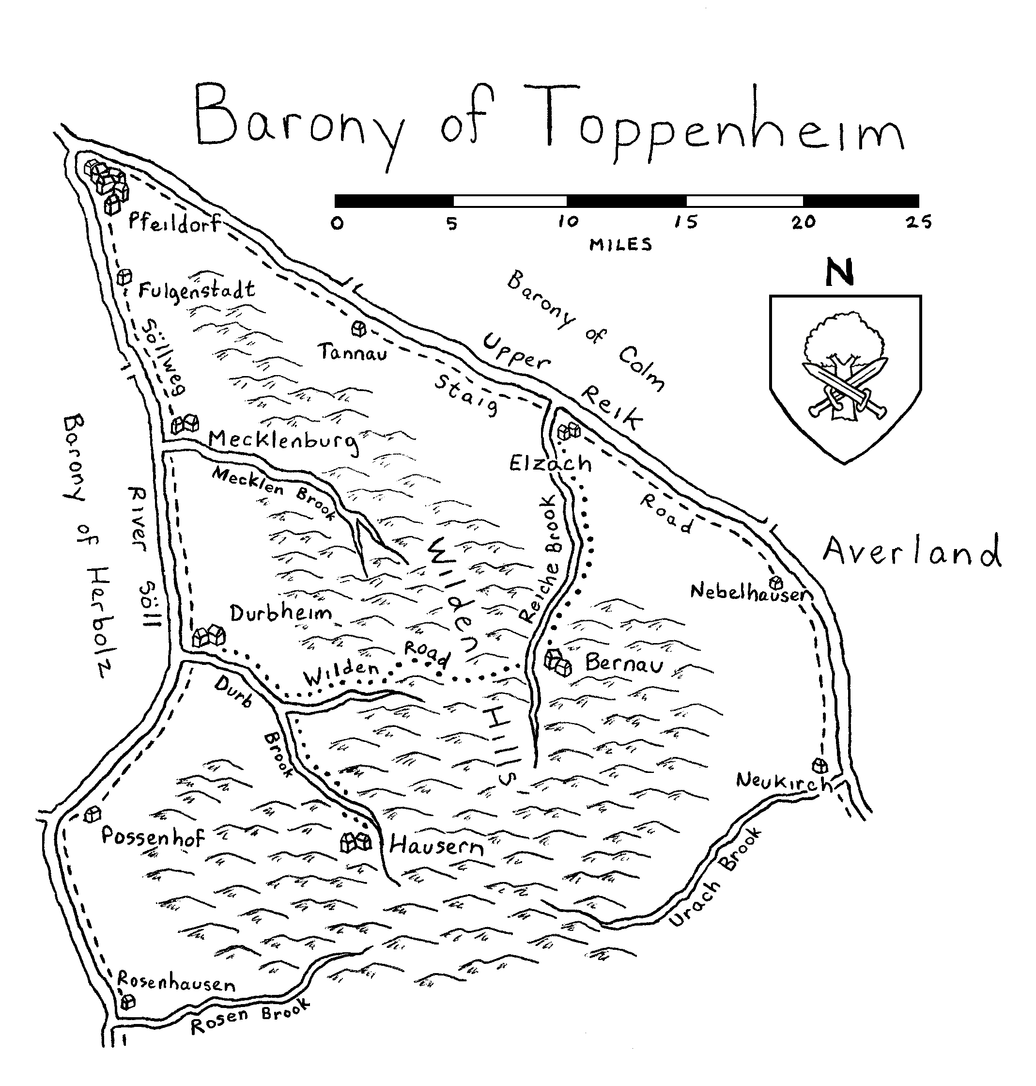

Map 2. Town of Pfeildorf (GM Map)
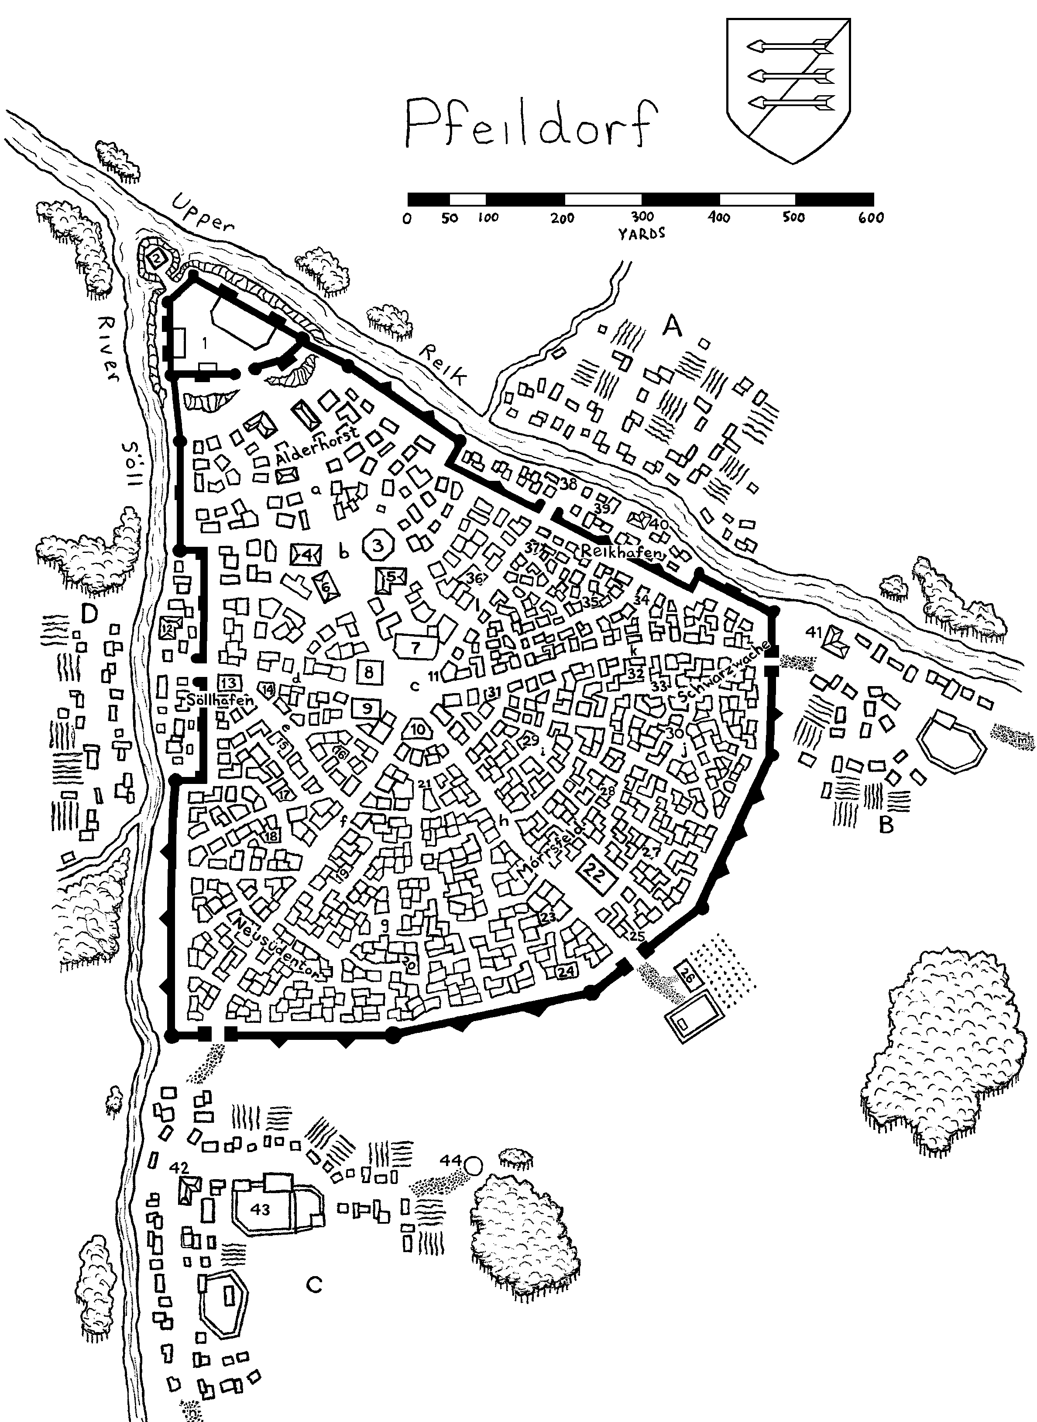

Map 3. Alderhorst District
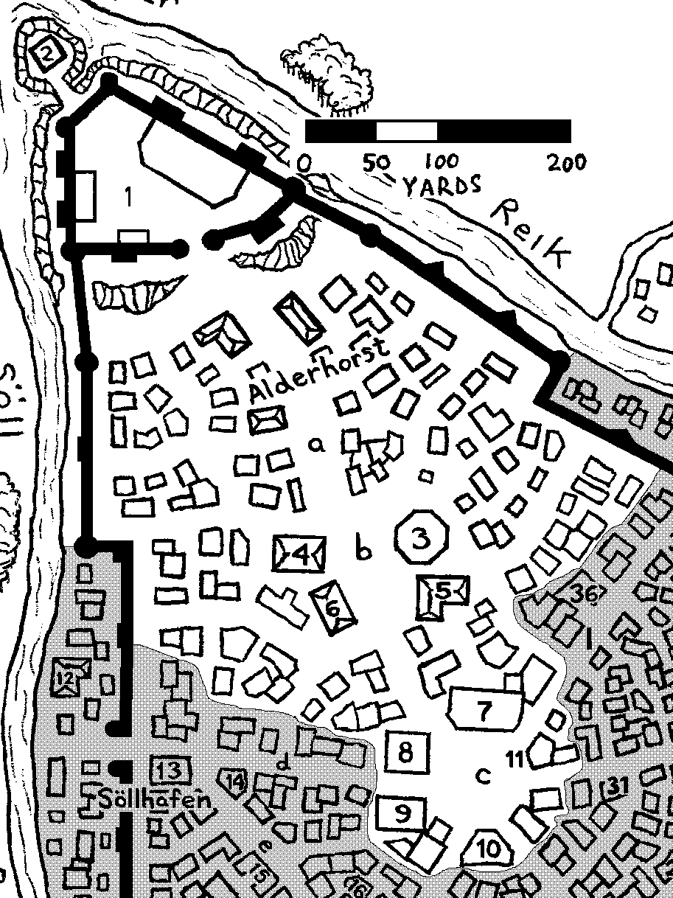

Map 4. Söllhafen district and village of Walnussbrun
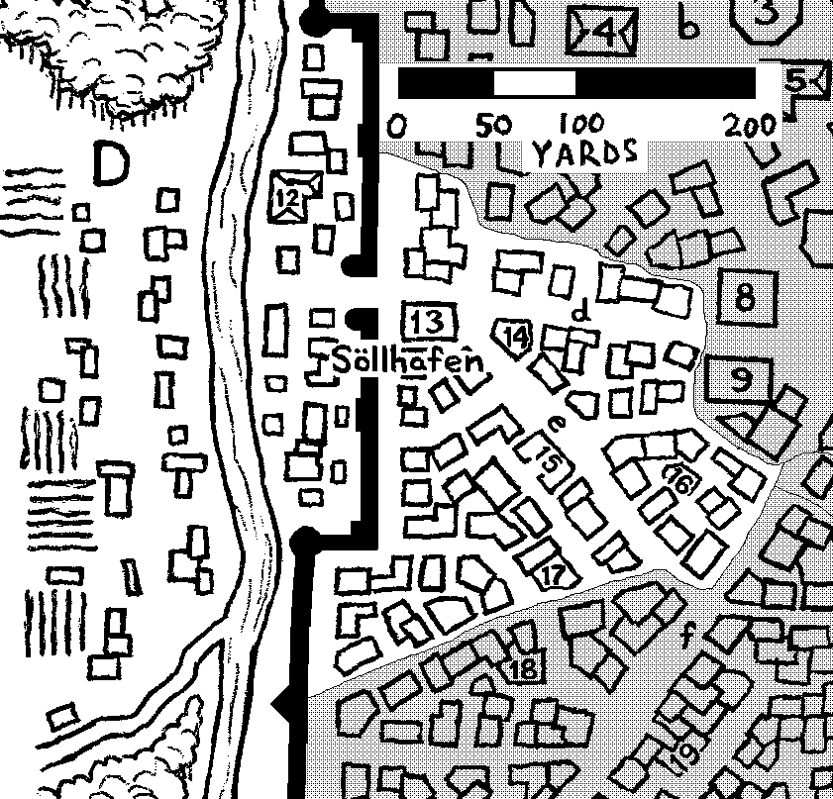

Map 5. Neusüdentor district and village of Gerechtfeld
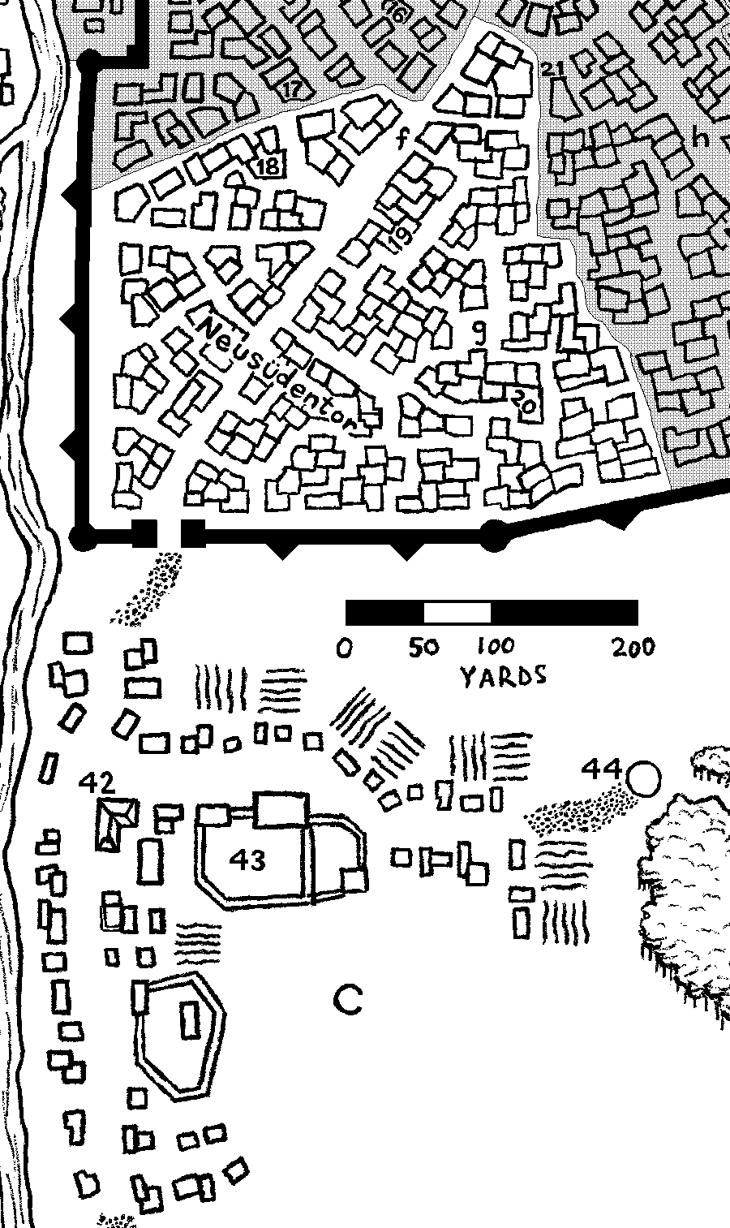

Map 6. Mórrsfeld district
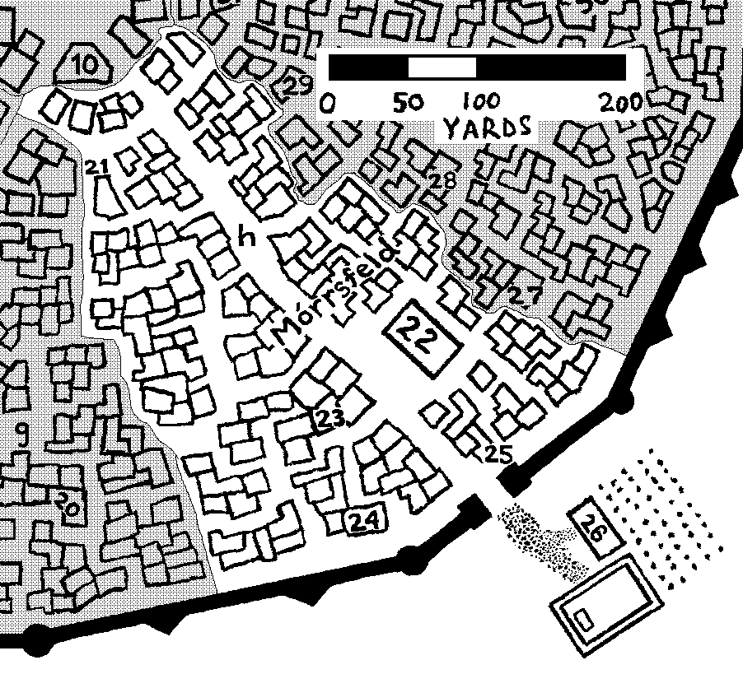

Map 7. Schwarzwache district and the village of Schaffenhof
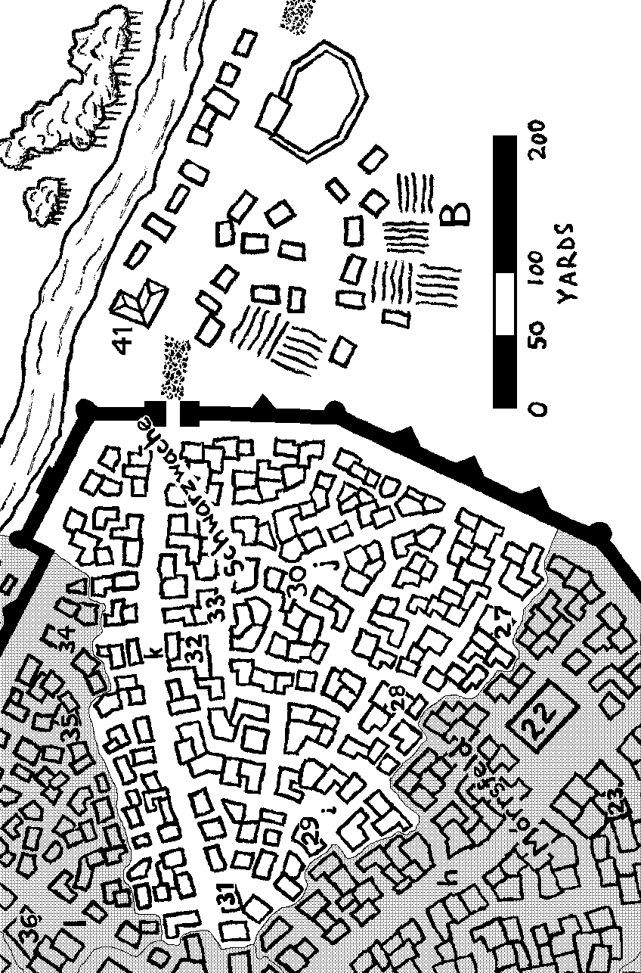

Map 8. Reikhafen district and the village of Merkelhausen
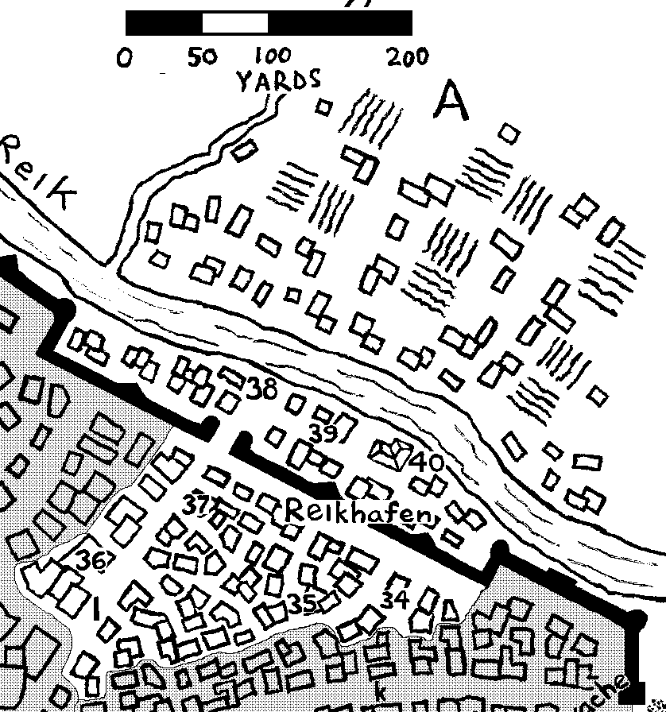

Map 9. Town of Pfeildorf (PC Map)
